* Find your mac address

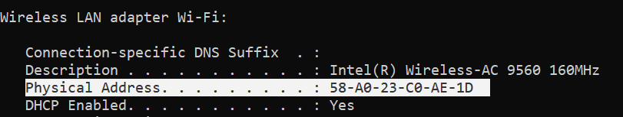

* Find your real (public) IP address

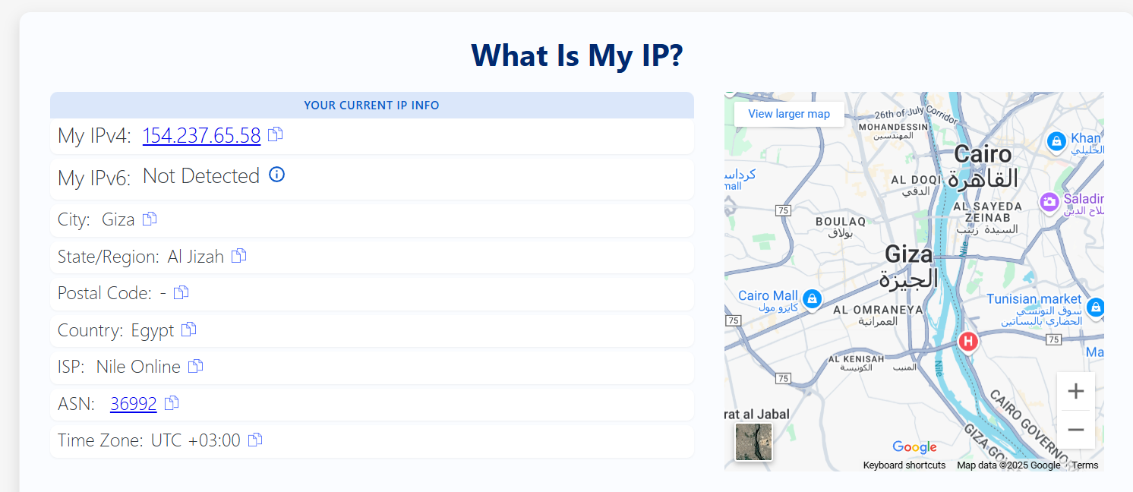

* Find your private IP address
  + Ipconfiq

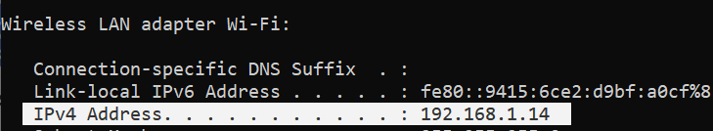

* Ipconfig /all

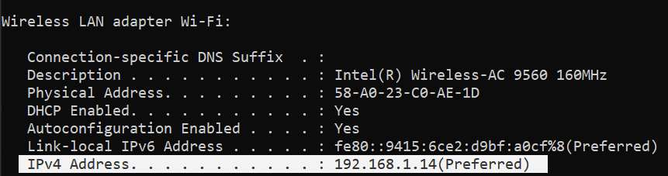

* These commands release and renew your IP from the DHCP server.
  + Ipconfig /release

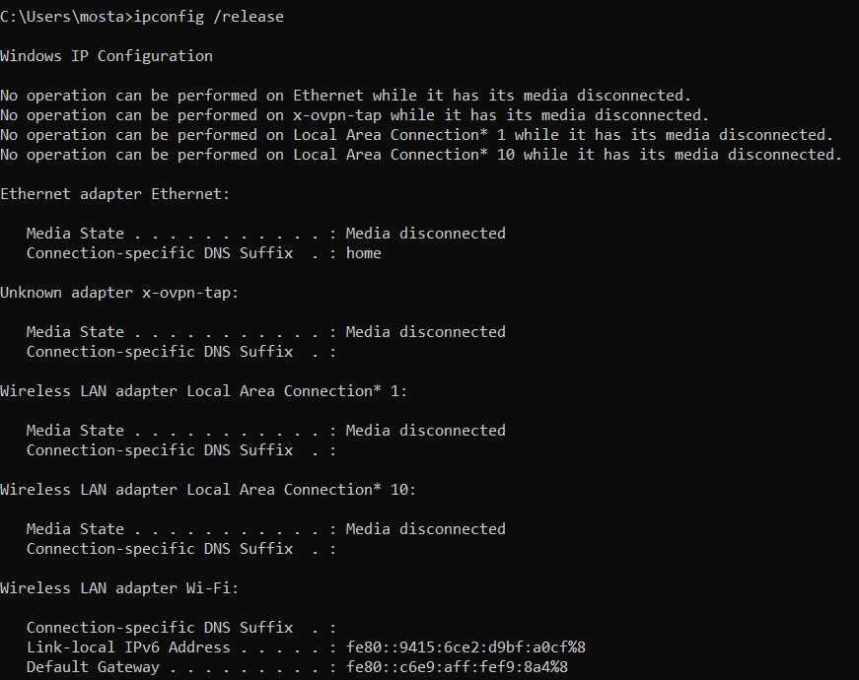

* + Ipconfiq /renew

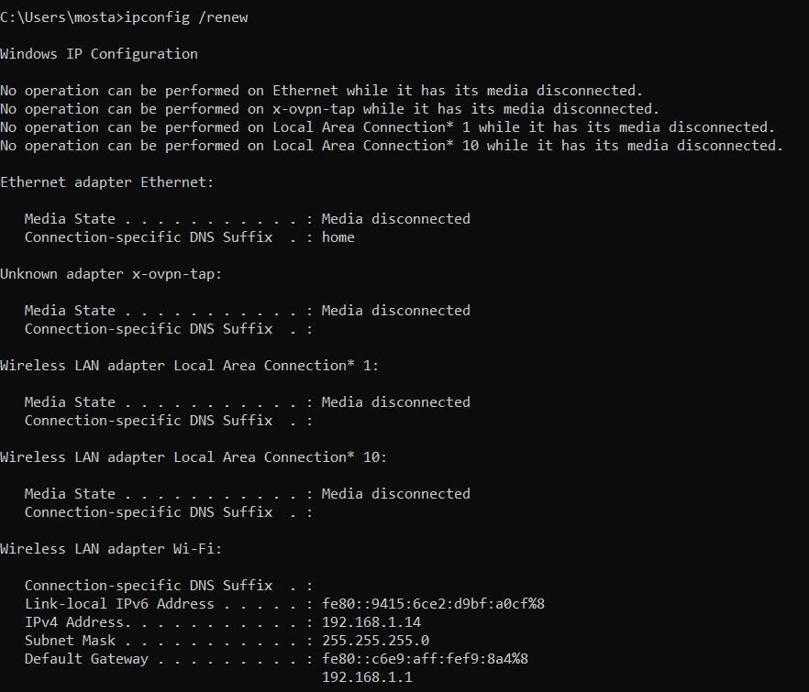

* Find current session and open ports
  + netstat -n
    - Shows active connections with IPs.

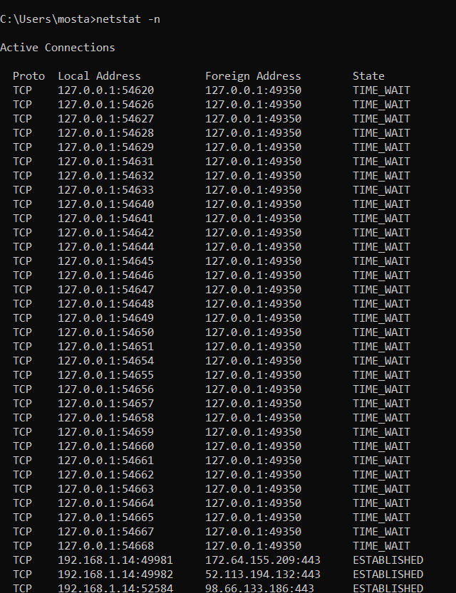

* + netstat -a
    - Shows all active ports and listening services.

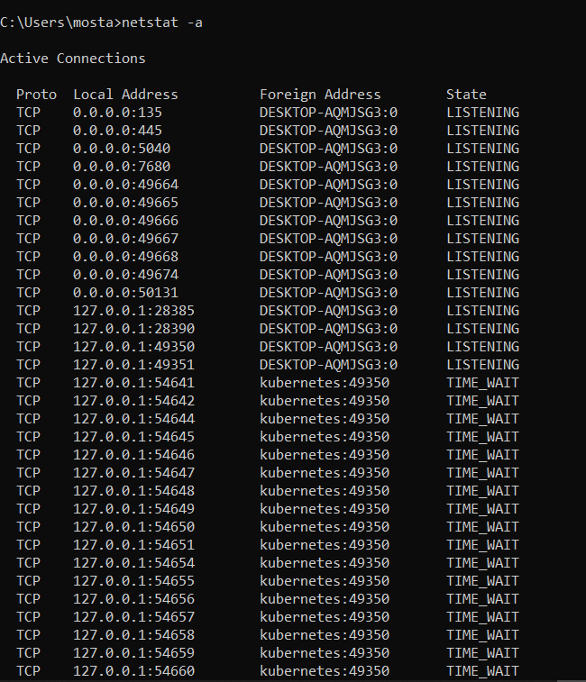

* Find the ip of the domain of yahoo
  + This will return the IP address(es) for Yahoo.com.

